Create Your Bucket List: Dream Big!

What do I want my health to be? _____________________________________________________
What does my spiritual life look like?
_____________________________________________________

Where do I want to travel?
_____________________________________________________

What does my social life look like?
_____________________________________________________

How is my relationship with my significant other?
_____________________________________________________

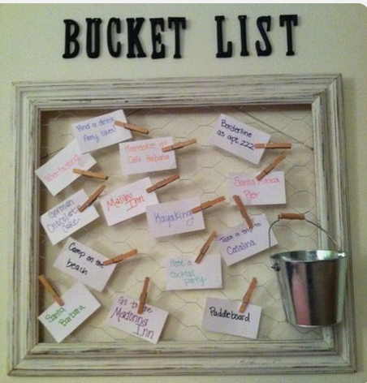
What do I want to accomplish this year?
_____________________________________________________

What is one thing my family really needs?
_____________________________________________________

What is one thing I desperately want to own?
_____________________________________________________

Who do I want to help?
_____________________________________________________

How much money do I want to make?
_____________________________________________________

What is my dream vacation/s?
_____________________________________________________

Any other dreams?
____________________________________________________________________________________________________________________________________________________________________________________________________________________

Some other areas of life to help you brainstorm and think big!
